**EXERCISE – 1**

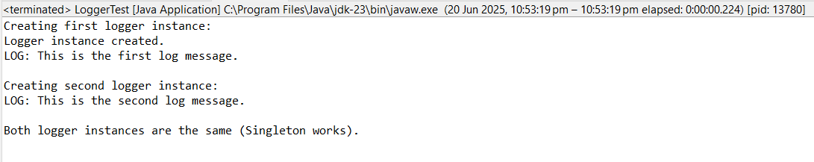

**EXERCISE – 2**

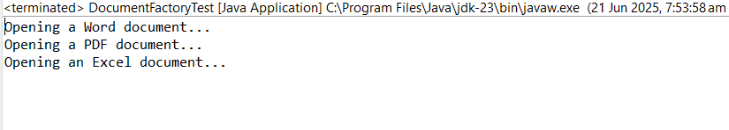

**EXERCISE – 3**

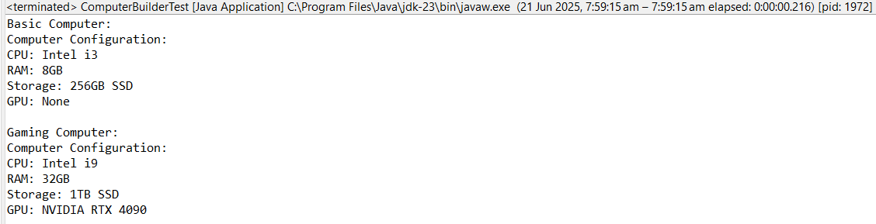

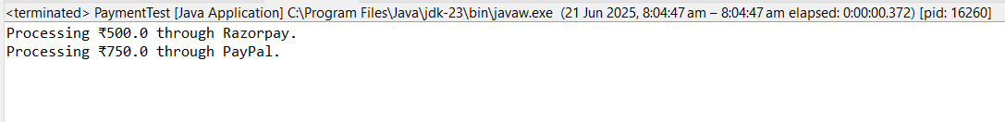**EXERCISE – 4**

**EXERCISE – 5**

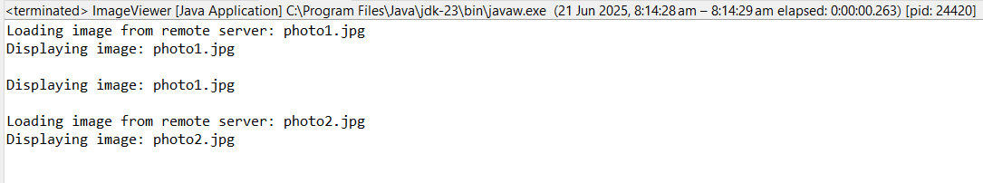**EXERCISE - 6**

**EXERCISE – 7**

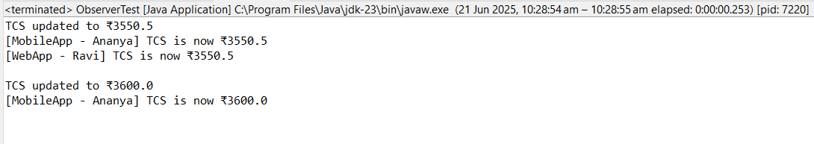

**EXERCISE – 8**

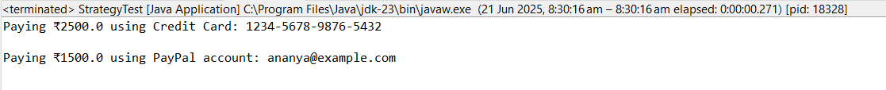

**EXERCISE – 9**

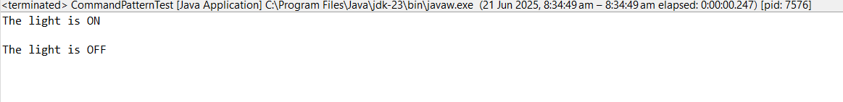

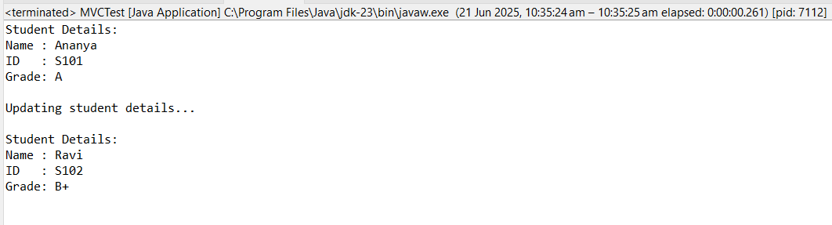**EXERCISE – 10**

**EXERCISE – 11**

